TRAINING REQUIREMENTS FOR BIOPACIFIC MIP FACILITY ACCESS

For visiting researchers, steps 1-9 can be completed prior to traveling to UC Santa Barbara.

- Provide your project participant information (If you have already submitted your information, please skip this step). For personnel that are being added after a project has been approved or started, please provide your Participant Information.

- UCSB NetID Registration (This step is not required for UCSB-based researchers).
- Visiting Researchers: Email Saejin Oh (saejinoh@ucsb.edu) to request an Annex Locator. Provide your university or professional email, full name, and date of birth.
- Once you receive the Annex Locator, request your UCSB netID using the UCSB Identity Manager as a University Affiliate. Send the netID you chose to Saejin Oh (saejinoh@ucsb.edu) so she can activate the account.

- Activate the Lab Hazard Assessment Program (Local UCSB researchers already added to another lab hazard assessment may skip this step).
- Log in to Assessment using your UCSB netID and log out.

- Complete the UC Laboratory Safety Fundamentals Course (UC-affiliated researchers can login to their own campus’ UC Learning Center to provide a copy of the class certificate.).
- Take the course online via the UCSB Learning Center and save the completion certificate.
- Email the certificate to Debbie Kleinpeter (BP-admin@cnsi.ucsb.edu).

- Submit the Chemical Hygiene Plan Attestation Form

- Read the SOPs and BioPACIFIC MIP Chemical Hygiene Plan,
- Read Section 2 of the UCSB Chemical Hygiene Plan.
- Read Section 3 of the UCSB Chemical Hygiene Plan.
- Download, sign, and email the Chemical Hygiene Plan Attestation Form to Debbie Kleinpeter (BP-admin@cnsi.ucsb.edu).

- For X-ray users only
- Complete the online Radiation Safety Training course titled “Radiation Producing Machines” via the UCSB Learning Center.
- Submit the completion certificate to Youli@mrl.ucsb.edu.

- For Symphony-X users only
- Complete the Symphony X Attestation Form and email it to zjnett@ucsb.edu.

- Schedule Instrument Training
- Once the above steps are completed, email the relevant project scientist to schedule your instrument training.
- Include your UCSB netID, PI name, department, university affiliation, BioPACIFIC MIP proposal ID/project code, or recharge account number.

- Acknowledge Your Addition to the Lab
- The project scientist will add you to the laboratory hazard assessment roster using your UCSB netID.
- Log in to Assessment and acknowledge the hazard safety assignment for the corresponding laboratory (OASIS 400 and 413 for Synthesis and Additive Manufacturing, Elings 2419 for X-ray or Elings 2417 for microrheology)

An example action item assignment in Assessment is shown below:
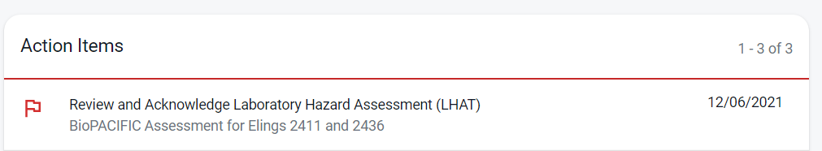

- PPE Safety Training and Pick-Up

- If you want your personal PPE please follow the procedure below.

- Complete the PPE Safety Training Course in the Assessment/LHAT.
- Schedule a PPE pick-up appointment via Google Calendar. Please provide required details: non-flammable lab coat, BioPACIFIC MIP as PI, preferred gender, and coat size.
- For your scheduled appointment, please go to the Environmental Health and Safety offices (Bldg. 557). Please contact Hector Acuña (hector.acuna@ucsb.edu) or Andrea Tufekcic (andreatufekcic@ucsb.edu) with questions regarding this process.

- Readily available shared PPE at different sizes will be available at the OASIS facilities.

- Lab Walkthrough

- Complete a laboratory safety walk-through with Zach Nett (zjnett@ucsb.edu) and/or David Fisher (dfisher@ucsb.edu) before gaining keycard access or unrestricted reservation access to equipment.
- Download the Training Needs Assessment Form and bring it to your session.

- Keycard access:

- For visiting researchers:
Email the Research Project Coordinator (saejinoh@ucsb.edu) to obtain a FOB for Elings and/or OASIS lab access. Return it on your last day at UCSB.
- For UCSB researchers:
- For Elings Hall Lab Access: Apply for CNSI card access or update your existing card using the CNSI online form (accessible via campus Wi-Fi or VPN).
- For OASIS Lab Access: Apply for OASIS lab access using the OASIS Access FOB request form to obtain a FOB that grants you access to OASIS labs.

- Equipment Reservations

- Following training, reserve equipment online using FBS with your UCSB netID.
- If using the equipment via an active proposal, ask a staff scientist to set up an internal BioPACIFIC MIP lab account for tracking usage.

- Shipping Address

For shipping reagents, samples, or supplies to BioPACIFIC MIP, please use the address below and include the name of the staff member you are working with in the attention line:

For SAXS samples

Attn: [Staff Name]/BioPACIFIC MIP
California Nanosystems Institute
Elings Hall Room 3448
Santa Barbara, CA 93106-6105

For all other samples

Attn: [Staff Name]/BioPACIFIC MIP
UCSB OASIS
71 S Los Carneros
Goleta, CA 93117

