TRAINING REQUIREMENTS FOR BIOPACIFIC MIP FACILITY ACCESS

For visiting researchers, steps 1-8 can be completed prior to traveling to UC Santa Barbara.

- A UCSB netID is required for all visiting researchers. Email Eleni Papananou (hellen@ucsb.edu) to first request an Annex Locator by providing your university or professional email address, full name, and date of birth. Once the Annex Locator has been received, use the identify manager service to activate a UCSB netID and setup your account as a University Affiliate. Note that this step is not required for UCSB-based researchers.

- Login to Assessment to activate the Assessment program using your UCSB netID and log out. Note that if you are a local UCSB researcher and have already been added to another lab hazard assessment, activating an account via this step is not necessary.

- Complete the “UC Laboratory Safety Fundamentals” course online through the UCSB Learning Center. Save a copy of the class certificate and e-mail it to Debbie Kleinpeter (BP-admin@cnsi.ucsb.edu). UC-affiliated researchers can login to their own campus’ UC Learning Center to provide a copy of the class certificate.

- Read the SOPs and Chemical Hygiene Plan for the BioPACIFIC MIP Facility and Section 2 and Section 3 of the UCSB Chemical Hygiene Plan. Download, sign, and submit the Chemical Hygiene Plan Attestation Form via e-mail to Debbie Kleinpeter (BP-admin@cnsi.ucsb.edu).

- For X-ray users only: Complete the online radiation safety training course “Radiation Producing Machines” available through the UCSB Learning Center. Save or print the certificate of completion and submit it to Youli@mrl.ucsb.edu.

- For Symphony-X users only: Complete the Symphony X attestation form and submit it to morganbates@ucsb.edu with your training request (see Step 7).

- Once the above steps are completed, email the appropriate project scientist for scheduling instrument training and request to be added to the laboratory hazard assessment roster. Provide in the email your UCSB netID, the PI name, department and university affiliation, and the BioPACIFIC MIP proposal ID or project code, or a recharge account number.

- The project scientist will add you to the laboratory hazard assessment roster using your UCSB netID. Once added, login to Assessment to acknowledge the hazard safety assignment for the corresponding laboratory (Elings 2411 and 2436 for Synthesis and Additive Manufacturing or Elings 2419 for X-ray). An example action item assignment in Assessment is shown below:
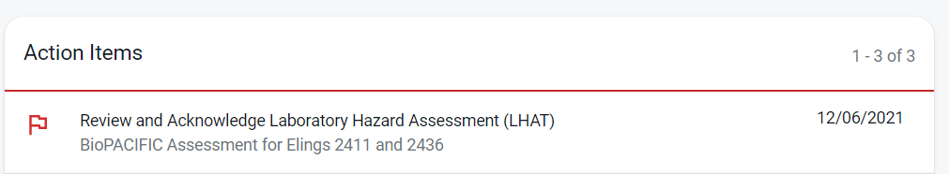

Under next steps, complete the PPE safety training course and schedule an appointment to pick-up your PPE from the chemistry department. In the google calendar reservation, indicate (i) the need for a flammable lab-coat, (ii) BioPACIFIC MIP as the PI, and (iii) your preferred gender and size of coat. At your scheduled appointment time go to the Chemistry Building loading dock outside of PPE storeroom #1432.
- A training needs assessment is a laboratory safety walk-through that is completed with a staff scientist prior to obtaining keycard access or unrestricted reservation access to equipment. A training needs assessment form can be downloaded here and brought to your equipment training session. This safety walk-through must be complete before keycard or reservation access will be approved.

- Keycard access:

- For visiting researchers: Email our User Coordinator (hellen@ucsb.edu) so she can provide you with an access card to enter the building and required labs. Return the card to her on your last day at UCSB.
- For UCSB researchers: Apply for CNSI card access or add lab access to an existing card using the online form. Access to the online form via the link below is only possible when connected to campus Wi-Fi or when logged on through a campus VPN:
http://access.cnsi.ucsb.edu/Forms/form.php

- Following training, reservations for equipment can be made online using FBS and your UCSB netID. If accessing the equipment through an active proposal, ask a staff scientist for assistance in setting up an BioPACIFIC MIP internal lab account and study for recording usage.

